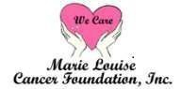

May 10, 2017

Dear Prospective Sponsor,

Marie Louise Cancer Foundation is pleased to announce the 3rd Annual “**Haitians & Friends United Against Breast Cancer Walk and Family Health Fair”,** scheduled for **Saturday, October 7, 2017** at the **Intracoastal Park** located at **2240 N. Federal Highway in Boynton Beach, Florida.**

Since 2006, The Marie Louise Cancer Foundation, a nonprofit 501(C) (3) organization, has been serving the medically underserved, uninsured and unprivileged cancer patients and their families in the South Florida area. This Walk and Health Fair objective is to provide the much needed Breast and Cervical Cancer awareness, education and medical assistance to the community and to raise funds so we can continue to provide these services in hopes of reducing the morbidity and mortality incidents resulting from late diagnoses of certain diseases, specifically cancers, in Haitians.

***We need your help and we hope we can count on you***! Your generous cash or in-kind donation will help us to defray the cost associated with putting on this very important event for our community. Please review the attached **Sponsorship Opportunities** and return the completed and signed agreement as soon as possible via email to [marieseide1@cs.com or](mailto:marieseide1@cs.com%20or) **fax to 561-364-7787.**

If you have any questions or require additional information, please feel free to contact me at 561-752-2122. We look forward to hearing from you and thank you for your consideration.

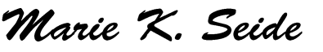Sincerely, Marie K. Seide

Founder/President

#### 625 SE 2nd Avenue, Suite B · Boynton Beach, FL 33435 Tel: (561) 752-2122 · Fax: (561) 364-7787

**mlcancerfoundation.org**



**HAITIANS & FRIENDS UNITED AGAINST BREAST CANCER**

**WALKATHON & HEALTH FAIR SATURDAY, OCTOBER 7, 2017 SPONSORSHIP OPPORTUNITIES**

|  |  |  |  |  |
| --- | --- | --- | --- | --- |
| **Sponsorship Benefits** | **SPONSORSHIP LEVELS** | | | |
| **Company Visibility & Recognition** | **PRESENTING**  **$5,000** | **GOLD**  **$3,000** | **SILVER**  **$2,000** | **BRONZE**  **$1,000** |
| Company Logo listed as ***Presenting Sponsor*** on all Event  Collaterals |  |  |  |  |
| Opportunity for Company Rep to Speak on Stage at Event  Ceremony |  |  |  |  |
| Company Name Mentioned as Presenting Sponsor on all  Radio Spots |  |  |  |  |
| Social Media Ads & Postings |  |  |  |  |
| Company Logo or Name listed as a Sponsor on all Event Press Releases | **LOGO** | **LOGO** |  |  |
| Company Logo or Name listed as Sponsor on Event T-Shirts (Deadline 9/10/17) | **LOGO** | **LOGO** | **NAME** | **NAME** |
| Company Logo or Name listed as Sponsor on Event Flyers | **LOGO** | **LOGO** | **NAME** | **NAME** |
| Company Logo or Name listed as Sponsor on Event Posters | **LOGO** | **LOGO** | **NAME** | **NAME** |
| Company Logo or Name listed as a Sponsor on Event Signage | **LOGO** | **LOGO** | **NAME** | **NAME** |
| Complimentary Table and 2 Chairs Provided on Event Day |  |  |  |  |
| VIP Parking Passes | **4** | **2** | **1** |  |
| Right to use Proud Sponsor of "Haitians United Against Breast Cancer Walk" |  |  |  |  |











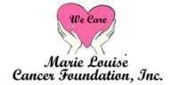

**October 7, 2017 • Intracoastal Park • Boynton Beach, FL**

**SPONSORSHIP AGREEMENT FORM**

#### Please Select Your Desired Sponsorship Level

 **Presenting—$5,000**  **Gold—$3,000**  **Silver—$2,000**  **Bronze—$1,000**

* **In-Kind Donation: Item: RMV: $ Quantity:**

**Company Name_**

**Contact Person_ Title_**

**Street Address**

**City ______________________________________State_________________Zip**

**Phone_ Fax Email**

**By signing this agreement, you commit to provide the selected level sponsorship for**

**“HAITIANS & FRIENDS UNITED AGAINST BREAST CANCER WALK & HEALTH FAIR”**

#### Please make your check payable to Marie Louise Cancer Foundation and mail to:

**MARIE LOUISE CANCER FOUNDATION—WALK & HEALTH FAIR**

625 SE 2nd Avenue, Suite B · Boynton Beach, Florida 33435

**Tel : (561) 752-2122 · Fax: (561) 364-7787 ·**

___________________________________ ___________________________________________

**Sponsor Representative Signature date Marie Louise Cancer Foundation Representative date**

**625 SE 2nd Avenue, Suite B · Boynton Beach, FL 33435**

**Tel: (561) 752-2122 · Fax: (561) 364-7787**

**mlcancerfoundation.org**

## HAIT IAN S & FRIEN DS UNITED

l k & Fa m i ly H e a

A G A I C E R

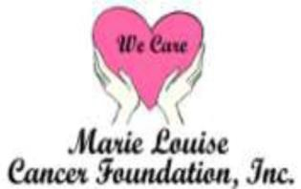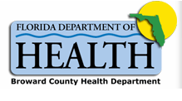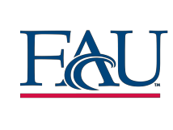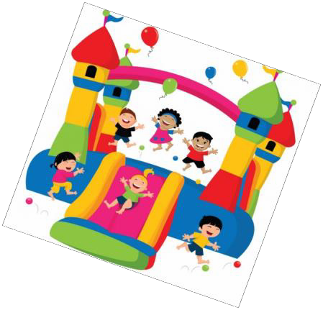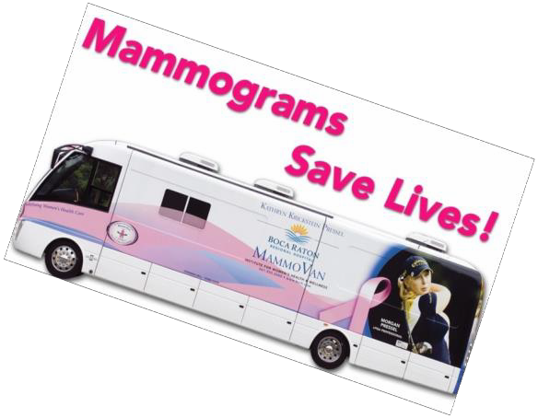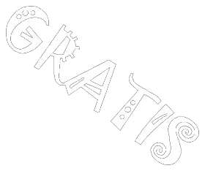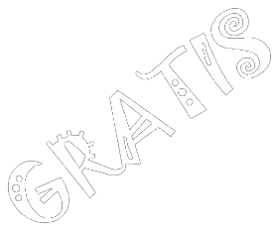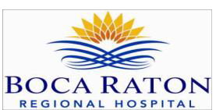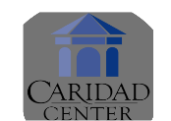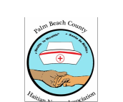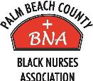

AGAINST BREAST CANCER

R FR FR FR

## Saturday October 7, 2017

Health Screenings & F u n Activities for the Entire Family

(Music, Food, Bounce House for the Kids & Lots of Free Stuff)

Pre - Registration Required f o r Mammogram & Pap - Smear

Fo k Ou Inskri Av a n Po u Mamogwam & Examen Pap

Call/Rele:

(561) 752- 2122

I NTRACOASTAL PARK

2 2 4 0 N Federal Highway , Boynton Beach, FL

8:00 AM—2:00

FOR SPONSORSORSHIP, VENDOR & VOLUNTEER OPPORTUNITIES

CALL : (56 1)752 -2122